U25AI055
Lab-8
- Reverse a queue
//1. Reverse queue
#include<iostream>
#include<stack>
using namespace std;
struct Node
{
int data;
Node* next;
};
void enqueue(Node **front,Node **rear,int item);
int dequeue(Node **front,Node **rear);
void reverse(Node **front,Node **rear);
int main()
{
Node *front=NULL,*rear=NULL;
int choice,item;
Node *p;
do
{
cout<<"1. Enqueue\n";
cout<<"2. Dequeue\n";
cout<<"3. Display elements\n";
cout<<"4. Reverse\n";
cout<<"Enter choice: ";
cin>>choice;
switch(choice)
{
case 1:
cout<<"Enter element: ";
cin>>item;
enqueue(&front,&rear,item);
break;
case 2:
item=dequeue(&front,&rear);
if(item!=-1) cout<<"Dequeued element="<<item<<endl;
else cout<<"Queue full\n";
break;
case 3:
p=front;
while(p!=NULL)
{
cout<<p->data<<"\t";
p=p->next;
}
cout<<endl;
break;
case 4:
reverse(&front,&rear);
break;
default:
cout<<"Invalid choice\n";
}
} while(choice>=1 && choice<=4);
return 0;
}
void enqueue(Node **front,Node **rear,int item)
{
Node *new_node;
new_node=new Node;
if(new_node==NULL) return;
new_node->data=item;
new_node->next=NULL;
if(*front==NULL && *rear==NULL)
{
*front=new_node;
*rear=new_node;
}
else
{
(*rear)->next=new_node;
*rear=new_node;
}
}
int dequeue(Node **front,Node **rear)
{
if(*front==NULL) return -1;
int item=(*front)->data;
Node *temp=*front;
if(*front==*rear)
{
*front=NULL;
*rear=NULL;
}
else *front=(*front)->next;
delete temp;
return item;
}
void reverse(Node **front,Node **rear)
{
stack<int> s1;
int item;
while(true)
{
item=dequeue(front,rear);
if(item==-1) break;
s1.push(item);
}
while(!s1.empty())
{
item=s1.top();
s1.pop();
enqueue(front,rear,item);
}
}
Output:
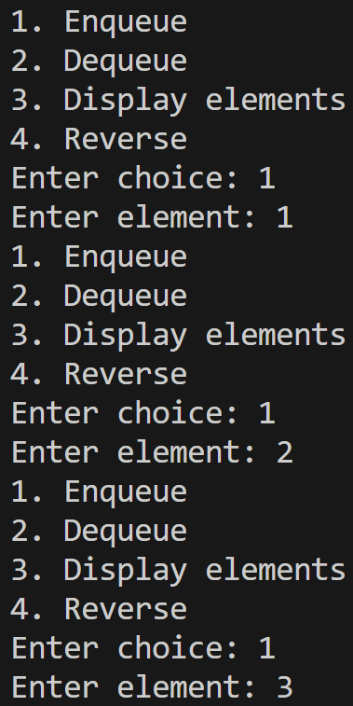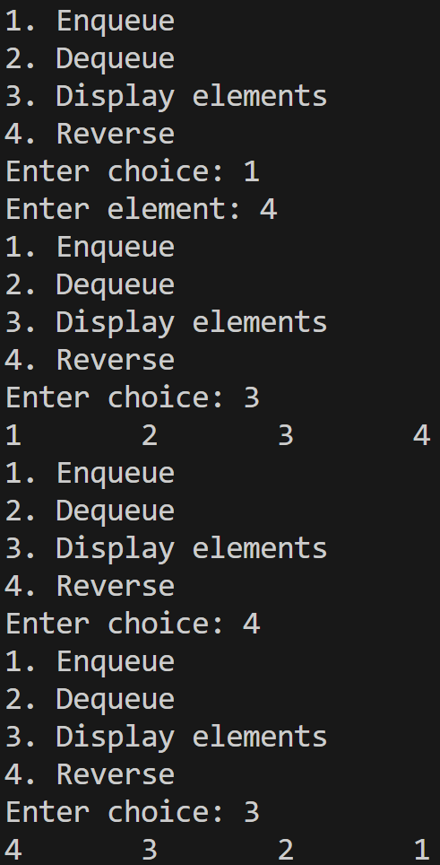
- Count number of elements in queue
//2. Count number of elements in queue
#include<iostream>
#define N 10
using namespace std;
void enqueue(int *queue,int *front,int *rear,int item);
int dequeue(int *queue,int *front,int *rear);
int main()
{
int *queue=new int[N];
int front=-1,rear=-1;
int choice,item;
do
{
cout<<"1. Enqueue\n";
cout<<"2. Dequeue\n";
cout<<"3. Display elements\n";
cout<<"4. Count number of elements\n";
cout<<"Enter choice: ";
cin>>choice;
switch(choice)
{
case 1:
cout<<"Enter element: ";
cin>>item;
enqueue(queue,&front,&rear,item);
break;
case 2:
item=dequeue(queue,&front,&rear);
if(item!=-1) cout<<"Dequeued element="<<item<<endl;
else cout<<"Queue full\n";
break;
case 3:
for(int i=front;i<=rear && i!=-1;i++) cout<<queue[i]<<"\t";
cout<<endl;
break;
case 4:
cout<<"Number of elements="<<rear-front+1<<endl;
break;
default:
cout<<"Invalid choice\n";
}
} while(choice>=1 && choice<=4);
cout<<"Number of elements="<<rear-front+1<<endl;
return 0;
}
void enqueue(int *queue,int *front,int *rear,int item)
{
if(*rear==N-1) return;
if(*front==-1 && *rear==-1) (*front)++;
queue[++*rear]=item;
}
int dequeue(int *queue,int *front,int *rear)
{
if(*front==-1) return -1;
if(*front==*rear)
{
*front=-1;
*rear=-1;
}
return queue[(*front)++];
}
Output:
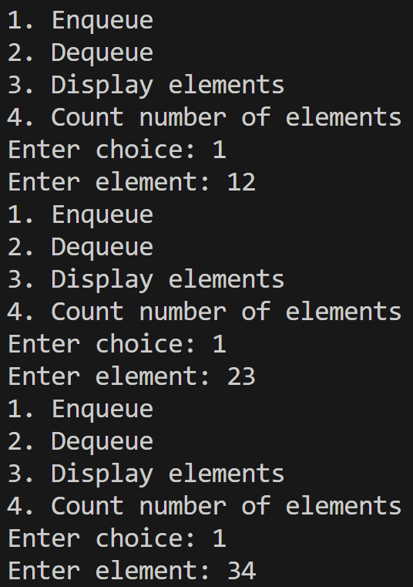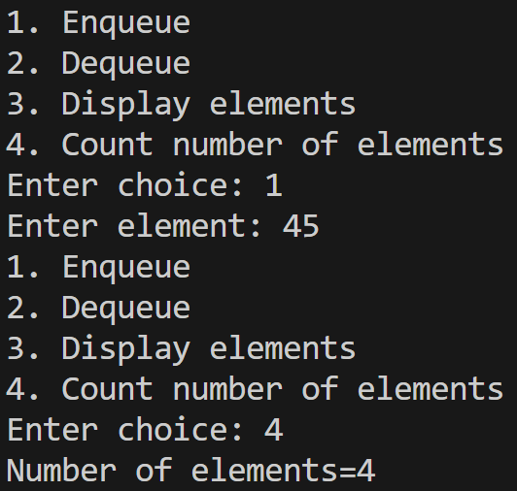
- Find maximum and minimum element in queue
//3. Find maximum and minimum element in queue
#include<iostream>
#include<climits>
using namespace std;
struct Node
{
int data;
Node* next;
};
struct Queue
{
Node *front;
Node *rear;
};
void enqueue(Queue *queue,int item);
int dequeue(Queue *queue);
int maximum(Queue *queue);
int minimum(Queue *queue);
int main()
{
Queue *queue=new Queue;
queue->front=NULL;
queue->rear=NULL;
int choice,item;
Node *p;
do
{
cout<<"1. Enqueue\n";
cout<<"2. Dequeue\n";
cout<<"3. Display elements\n";
cout<<"4. Maximum element\n";
cout<<"5. Minimum element\n";
cout<<"Enter choice: ";
cin>>choice;
switch(choice)
{
case 1:
cout<<"Enter element: ";
cin>>item;
enqueue(queue,item);
break;
case 2:
item=dequeue(queue);
if(item!=-1) cout<<"Dequeued element="<<item<<endl;
else cout<<"Queue full\n";
break;
case 3:
p=queue->front;
while(p!=NULL)
{
cout<<p->data<<"\t";
p=p->next;
}
cout<<endl;
break;
case 4:
cout<<"Maximum element="<<maximum(queue)<<endl;
break;
case 5:
cout<<"Minimum element="<<minimum(queue)<<endl;
break;
default:
cout<<"Invalid choice\n";
}
} while(choice>=1 && choice<=5);
return 0;
}
void enqueue(Queue *queue,int item)
{
Node *new_node;
new_node=new Node;
if(new_node==NULL) return;
new_node->data=item;
new_node->next=NULL;
if(queue->front==NULL && queue->rear==NULL)
{
queue->front=new_node;
queue->rear=new_node;
}
else
{
(queue->rear)->next=new_node;
queue->rear=new_node;
}
}
int dequeue(Queue *queue)
{
if(queue->front==NULL) return -1;
int item=(queue->front)->data;
Node *temp=queue->front;
if(queue->front==queue->rear)
{
queue->front=NULL;
queue->rear=NULL;
}
else queue->front=(queue->front)->next;
delete temp;
return item;
}
int maximum(Queue *queue)
{
Node *p=queue->front;
int max=INT_MIN;
while(p!=NULL)
{
if(p->data>max) max=p->data;
p=p->next;
}
return max;
}
int minimum(Queue *queue)
{
Node *p=queue->front;
int min=INT_MAX;
while(p!=NULL)
{
if(p->data<min) min=p->data;
p=p->next;
}
return min;
}
Output:
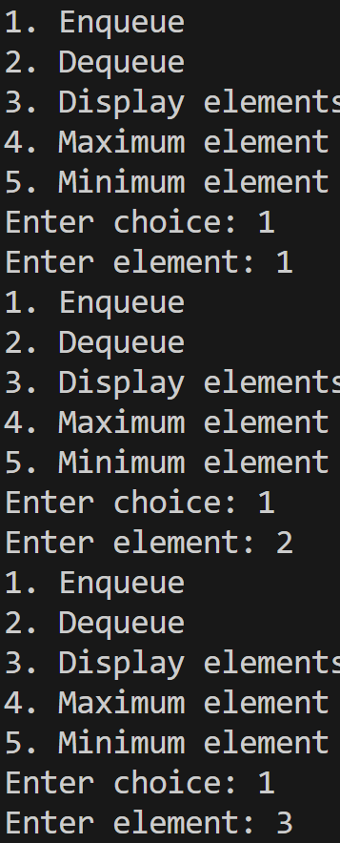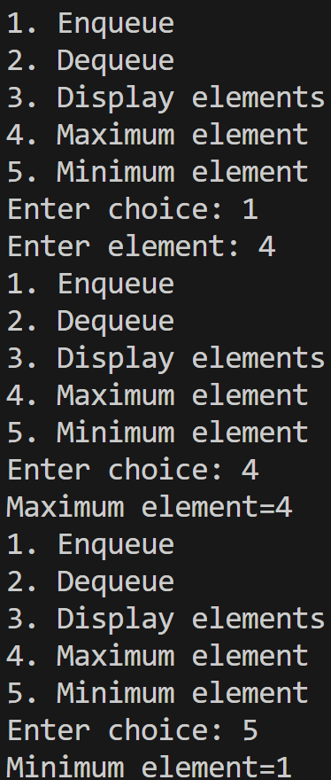
- Check palindrome using queue
//4. Check palindrome using deque
#include<iostream>
using namespace std;
struct Node
{
int data;
Node *next;
};
void insert_front(Node **front,Node **rear,int item);
void insert_rear(Node **front,Node **rear,int item);
int delete_front(Node **front,Node **rear);
int delete_rear(Node **front,Node **rear);
bool is_palindrome(Node **front,Node **rear,char *str);
int main()
{
Node *front=NULL,*rear=NULL;
char str[30];
cout<<"Enter string: ";
cin>>str;
if(is_palindrome(&front,&rear,str)) cout<<"Palindrome\n";
else cout<<"Not palindrome\n";
return 0;
}
void insert_front(Node **front,Node **rear,int item)
{
Node *new_node=new Node;
if(new_node==NULL) return;
new_node->data=item;
new_node->next=*front;
*front=new_node;
}
void insert_rear(Node **front,Node **rear, int item)
{
Node *new_node=new Node;
if(new_node==NULL) return;
new_node->data=item;
new_node->next=NULL;
if(*front==NULL && *rear==NULL)
{
*front=new_node;
*rear=new_node;
}
else
{
(*rear)->next=new_node;
*rear=new_node;
}
}
int delete_front(Node **front,Node **rear)
{
if(*front==NULL) return -1;
int item=(*front)->data;
if(*front==*rear)
{
delete *front;
*front=NULL;
*rear=NULL;
}
else
{
Node *temp=*front;
*front=(*front)->next;
delete temp;
}
return item;
}
int delete_rear(Node **front,Node **rear)
{
if(*front==NULL) return -1;
int item=(*rear)->data;
if(*front==*rear)
{
*front=NULL;
delete *rear;
*rear=NULL;
}
else
{
Node *p=*front,*q=*front;
while(p->next!=NULL)
{
q=p;
p=p->next;
}
q->next=NULL;
*rear=q;
delete p;
}
return item;
}
bool is_palindrome(Node **front,Node **rear,char *str)
{
int i=0;
while(str[i]!='\0')
{
insert_rear(front,rear,str[i]);
i++;
}
while(*front!=NULL && *rear!=NULL)
{
if(*front==*rear || (*front)->next==*rear) break;
int f=delete_front(front,rear),r=delete_rear(front,rear);
if(f!=r) return false;
}
return true;
}
Output:
